Lab 1: Windows Installation 2
Lab 2: User Account and Application Management 2
Lab 3: OS Installation in Virtual Box 3
Lab 4: User, Group and Application Management 4
Lab 5: Command line interface in Linux 5
Lab 6: CPU Scheduling Simulation using FCFS without arrival time 7
Lab 7: CPU Scheduling Simulation using FCFS with arrival time 10
Lab 8: CPU Scheduling Simulation (SJF) 15
Lab 9: CPU Scheduling Simulation (Round Robin) 19
Lab 10: CPU Scheduling Simulation (Priority based) 22
Lab 11: Page Replacement Simulation using FIFO 25
Lab 12: Page Replacement Simulation using OPT 27
Lab 13: Page Replacement Simulation LRU 28
Lab 14: Page Replacement Simulation Clock 29
Lab 15: Page Replacement Simulation using LFU 29
Lab 16: Disk Scheduling using FCFS 31
Lab 17: Disk Scheduling using SSTF 32
Lab 18: Disk Scheduling using SCAN 32
Lab 19: Disk Scheduling using C-SCAN 35
Lab 20: Disk Scheduling using LOOK 37
Lab 21: Disk Scheduling using C-LOOK 37
Lab 22: 38
Lab 20: Simulate Banker’s Algorithm for Deadlock Avoidance 38
Lab 21: Simulate Banker’s Algorithm for Deadlock Prevention 42
Lab 22: Mini OS Model (User Space) 43
Lab 23: Simple Shell programming 44
Lab 24: 44

Lab 1: Windows Installation

Objectives
Students will create a bootable media and install Windows.

Requirements
- Windows ISO file
- USB drive (min 8 GB)
- Rufus or media creation tools
- VirtualBox/VMware

Procedures
- Download Windows ISO and Rufus.
- Open Rufus -> Select ISO file -> Choose partition scheme (MBR/GPT) -> Start.
- Boot from USB and begin Windows installation.
- Select language, time, keyboard layout.
- Choose installation type: Update or custom.
- Partition disk (NTFS file system recommended).
- Continue installation and restart system.
- Complete initial setup.

Questions for students:
- Why NTFS instead of FAT32?
- What is difference between MBR and GPT?
- What is difference between upgrade and custom installations?

Lab 2: User Account and Application Management

Objectives
Students will learn to create and manage user accounts and roles in windows. They will later install, update and remove application in Windows.

Procedures
- Create a local user via Settings -> Accounts-> Family and other users.
- Create a local user via control panel -> User Accounts.
- Use Computer Management -> Local Users and Groups.
  - Examine built-in accounts (Administrator, Guest).
  - Enable/disable accounts, reset passwords, and change roles.
- Install an Application (VS code)
- Verify installation by launching app.
- Remove application: Control Panel -> Programs and Features -> Uninstall.

Questions:
- Why are the Administrator disabled by default?
- What are security concerns with Guest Accounts?
- What is difference between uninstalling and disabling application?
- How to delete residues of uninstalled application?

Lab 3: OS Installation in Virtual Box

Objectives
Students will install a Linux distribution (Ubuntu) and configure basic system settings

Requirements
- ISO file (Ubuntu 22.04 LTS or kali)
- VirtualBox/VMware
- System with 4GB+ RAM

Procedures
- Download Linux ISO from official website.
- Create bootable media (Rufus).
- Boot system /VM from ISO.
- Select Install Linux option.
- Partition disk:
  - Guided (use entire disk)
  - Manual (/root/home, swap partitions)
- Configure language, time zone, keyboard layout, and user account.
- Finish installation and reboot.

Lab 4: User, Group and Application Management

Objectives
Students will learn to create, modify, and manage Linux users and groups. They will also lean to install, update, and remove applications using package managers.

Procedures
- Check current user:
whoami
id
- Add new user:
sudo adduser student1
sudo su
exit
- Update repositories:
Sudo apt update
- Install an application (firefox)
sudo apt install firefox -y
- Verify installation
code –version
- Remove application:
sudo apt remove code
- Remove unnecessary packages:
sudo apt autoremove

Lab 5: Command line interface in Linux

Objectives
Execution of basic commands used in Unix/Linux system.

Description
Open terminal. The terminal shows username and the prompt ($), after the prompt start the commands with different options.
The syntax of commands [command] [-options] [arg1, arg2…].
- pwd : to see the current or working directory
- mkdir : make a new directory
- ls : to see the list of file and directory
- ls -a: to see all file (hidden also)
- ls -l : to see the default permission of files
- cd <directory name>: to move inside folder cd .. get out of the directory
- touch <filename>: to create file
- cat <filename> : read content of filename
- less <filename> : reads file (page by page)
- nano <filename> : to read and write ctrl + o to save and ctrl + X to exit
- cat > filename.txt : to write in file
- copy <source> <destination>
- move <source> <destination>
- rename <oldname> <newname>
- rm <filename> : to remove file
- rmdir <dirname> : to remove directory

Q1. Display your present working directory.
pwd
Q2. Display Calander of your birthday. Also check various options.
Q3. Display current date. Also check various options.
Q4. Check whether the following commands are built-in or external commands:
pwd, cd, man, cat, file, echo, who, ls.
Q5. Check “help”, “man” and explain their purpose.
Q8. Create a directory using your name.
Q9. Create two files by the name f1.txt, f2.txt.
Q10. Analyze the default permission of both files.
Q7. Display all the files and directory including hidden files in your system in home directory.
Q11. Delete file, then delete directory.

Lab 6: CPU Scheduling Simulation using FCFS without arrival time

Objectives:
Simulate basic CPU algorithm
Calculate turnaround and waiting times

Algorithm:
- Start
- Input number of processes n.
- Input burst time BT[i] for each process P[i] for i = 1...n.
- Set current_time = 0.
- For i = 1 to n (processes in the given order):
  - StartTime[i] = current_time.
  - FinishTime[i] = StartTime[i] + BT[i].
  - WaitingTime[i] = StartTime[i] (since arrival = 0).
  - TurnAroundTime[i] = FinishTime[i] (since arrival = 0).
  - current_time = FinishTime[i].
- Compute Average Waiting Time = sum(WaitingTime[i]).
- Compute Average Turnaround Time = sum(TurnAroundTime[i]).
- Output Start, Finish, Waiting, Turnaround times and the averages.
- Stop

Pseudocode:
Input n
for i = 1 to n:
input BT[i]

current_time = 0
total_WT = 0
total_TAT = 0
for i = 1 to n:
StartTime[i] = current_time
FinishTime[i] = StartTime[i] + BT[i]
WaitingTime[i] = StartTime[i] // arrival assumed 0
TurnAroundTime[i] = FinishTime[i] // arrival assumed 0
total_WT += WaitingTime[i]
total_TAT += TurnAroundTime[i]
current_time = FinishTime[i]

avg_WT = total_WT / n
avg_TAT = total_TAT / n

print results

Program:
#include <stdio.h>

int main()
{
int burst[10], pid[10];
int start[10], finish[10], wait[10], turn[10];
int i, n;

float totalwait = 0.0, totalturn = 0.0;

printf("Name: Kapil Dev Pant \n");
printf("Enter number of processes: ");
scanf("%d", &n);

// Input Burst Times
for (i = 0; i < n; i++)
{
pid[i] = i + 1;
printf("Enter Burst time of Process %d: ", i + 1);
scanf("%d", &burst[i]);
}

// FCFS Scheduling (All arrival = 0)
start[0] = 0;
finish[0] = burst[0];

for (i = 1; i < n; i++)
{
start[i] = finish[i - 1];
finish[i] = start[i] + burst[i];
}

// Calculate turnaround and waiting time
for (i = 0; i < n; i++)
{
turn[i] = finish[i]; // arrival = 0
wait[i] = turn[i] - burst[i];

totalwait += wait[i];
totalturn += turn[i];
}

// Output
printf("\nProcess\tBurst\tStart\tFinish\tTurn\tWait\n");
for (i = 0; i < n; i++)
{
printf("P%d\t%5d\t%5d\t%6d\t%4d\t%4d\n",
pid[i], burst[i], start[i], finish[i], turn[i], wait[i]);
}

printf("\nAverage Waiting Time: %.2f\n", totalwait / n);
printf("Average Turnaround Time: %.2f\n", totalturn / n);

return 0;
}

Output
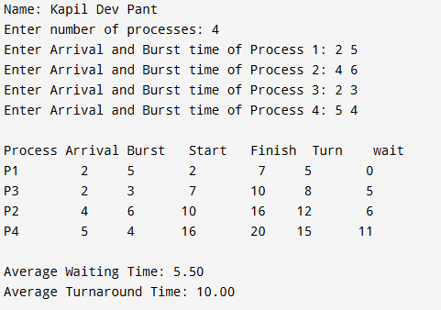

Lab 7: CPU Scheduling Simulation using FCFS with arrival time

Objectives:
Simulate basic CPU algorithm
Calculate turnaround and waiting times

Algorithm:
- Start
- Read the number of processes n
- For each process i
  - Input Arrival Time and Burst Time
  - Assign a Process ID
- Sort all processes in ascending order of Arrival Time
(If arrival times are equal, smaller PID comes first)
- Set start[0] = arrival[0]
- Compute finish[0] = start[0] + burst[0]
- For each process i = 1 to n-1
If previous finish time < arrival time
CPU is idle → start[i] = arrival[i]
Else
start[i] = finish[i - 1]
Compute finish[i] = start[i] + burst[i]
- For each process
Turnaround time = finish[i] - arrival[i]
Waiting time = turnaround - burst[i]
- Compute Average Turnaround Time and Average Waiting Time
- Display the results
- Stop

Pseudocode:
BEGIN
INPUT n
FOR i = 1 TO n DO
pid[i] = i
INPUT arrival[i], burst[i]
END FOR
// Sort by arrival time
FOR i = 1 TO n-1 DO
FOR j = i+1 TO n DO
IF arrival[j] < arrival[i] THEN
SWAP arrival[i], arrival[j]
SWAP burst[i], burst[j]
SWAP pid[i], pid[j]
END IF
END FOR
END FOR
start[1] = arrival[1]
finish[1] = start[1] + burst[1]

FOR i = 2 TO n DO
IF finish[i-1] < arrival[i] THEN
start[i] = arrival[i]
ELSE
start[i] = finish[i-1]
END IF

finish[i] = start[i] + burst[i]
END FOR

FOR i = 1 TO n DO
turn[i] = finish[i] - arrival[i]
wait[i] = turn[i] - burst[i]
END FOR

COMPUTE average waiting time
COMPUTE average turnaround time

DISPLAY all process values
END

Program:
#include <stdio.h>
int main()
{
int arrival[10], burst[10], pid[10];
int start[10], finish[10], wait[10], turn[10];
int i, j, n;

float totalwait = 0.0, totalturn = 0.0;

printf("Name: Kapil Dev Pant \n");
printf("Enter number of processes: ");
scanf("%d", &n);

// Input
for (i = 0; i < n; i++)
{
pid[i] = i + 1;
printf("Enter Arrival and Burst time of Process %d: ", i + 1);
scanf("%d %d", &arrival[i], &burst[i]);
}

// SORT BY ARRIVAL TIME (if all arrival same then → lower PID first)
for (i = 0; i < n - 1; i++)
{
for (j = i + 1; j < n; j++)
{
if (arrival[j] < arrival[i] ||
(arrival[j] == arrival[i] && pid[j] < pid[i]))
{
// Swap arrival
int temp = arrival[i];
arrival[i] = arrival[j];
arrival[j] = temp;

// Swap burst
temp = burst[i];
burst[i] = burst[j];
burst[j] = temp;

// Swap process ID
temp = pid[i];
pid[i] = pid[j];
pid[j] = temp;
}
}
}

// FCFS Scheduling Calculations

start[0] = arrival[0];
finish[0] = start[0] + burst[0];

for (i = 1; i < n; i++)
{
if (finish[i - 1] < arrival[i])
start[i] = arrival[i]; // CPU idle
else
start[i] = finish[i - 1];

finish[i] = start[i] + burst[i];
}

// Calculate turnaround and wait time
for (i = 0; i < n; i++)
{

turn[i] = finish[i] - arrival[i];
wait[i] = turn[i] - burst[i];

totalwait += wait[i];
totalturn += turn[i];
}

// Output

printf("\nProcess\tArrival\tBurst\tStart\tFinish\tTurn\twait\n");
for (i = 0; i < n; i++)
{
printf("P%d\t%7d\t%5d\t%5d\t%6d\t%4d\t%4d\n",
pid[i], arrival[i], burst[i], start[i], finish[i], turn[i], wait[i]);
}

printf("\nAverage Waiting Time: %.2f\n", totalwait / n);
printf("Average Turnaround Time: %.2f\n", totalturn / n);

return 0;
}

Output


Lab 8: CPU Scheduling Simulation (SJF)

Objectives
Simulate
Calculate turnaround and waiting times

Algorithm
- Start
- Input number of processes n
- Input Arrival Time & Burst Time for each process
- Set all processes as not completed
- Set current_time = 0
- While not all processes completed:
  - Among all processes that have arrived (arrival[i] <= current_time) and not completed
  - choose the one with the smallest burst time
If no process has arrived
current_time++
Else
Set start time
finish time = start + burst
mark process as completed
move current_time to finish time
- Calculate Waiting & Turnaround Time
- Display results
- Stop

Pseudocode
BEGIN
INPUT n
FOR each process i
INPUT arrival[i], burst[i]
completed[i] = false
END FOR
current_time = 0
finished = 0
WHILE finished < n DO
min_burst = ∞
selected = -1
FOR each process i
IF arrival[i] <= current_time AND completed[i] = false THEN
IF burst[i] < min_burst THEN
min_burst = burst[i]
selected = i
END IF
END IF
END FOR

IF selected = -1 THEN
current_time = current_time + 1
ELSE
start[selected] = current_time
finish[selected] = current_time + burst[selected]
completed[selected] = true
current_time = finish[selected]
finished = finished + 1
END IF
END WHILE

FOR each process i
turn[i] = finish[i] - arrival[i]
wait[i] = turn[i] - burst[i]
END FOR

DISPLAY results
END

Program:
#include <stdio.h>

int main()
{
int pid[20], arrival[20], burst[20];
int start[20], finish[20], wait[20], turn[20];
int completed[20] = {0};
int n, i, time = 0, completed_count = 0;

float total_wait = 0, total_turn = 0;

printf("Your name: Kapil Dev Pant");
printf("Enter number of processes: ");
scanf("%d", &n);

for (i = 0; i < n; i++)
{
pid[i] = i + 1;
printf("Enter Arrival and Burst time for Process %d: ", i + 1);
scanf("%d %d", &arrival[i], &burst[i]);
}

// SJF ko main logic
while (completed_count < n)
{
int idx = -1;
int min_burst = 99999;

// find the shortest job among arrived processes
for (i = 0; i < n; i++)
{
if (!completed[i] && arrival[i] <= time)
{
if (burst[i] < min_burst)
{
min_burst = burst[i];
idx = i;
}
}
}

// If no process has arrived, CPU is idle → jump to next arrival
if (idx == -1)
{
int next_arrival = 99999;
for (i = 0; i < n; i++)
{
if (!completed[i] && arrival[i] < next_arrival)
next_arrival = arrival[i];
}
time = next_arrival;
continue;
}

// Process selected → run it
start[idx] = time;
finish[idx] = time + burst[idx];
wait[idx] = start[idx] - arrival[idx];
turn[idx] = finish[idx] - arrival[idx];

total_wait += wait[idx];
total_turn += turn[idx];

completed[idx] = 1;
completed_count++;

time = finish[idx];
}

// OUTPUT
printf("\nProcess\tArrival\tBurst\tStart\tFinish\tWait\tTurn\n");
for (i = 0; i < n; i++)
{
printf("P%d\t%7d\t%5d\t%5d\t%6d\t%4d\t%4d\n",
pid[i], arrival[i], burst[i], start[i], finish[i], wait[i], turn[i]);
}

printf("\nAverage Waiting Time: %.2f\n", total_wait / n);
printf("Average Turnaround Time: %.2f\n", total_turn / n);

return 0;
}

Output
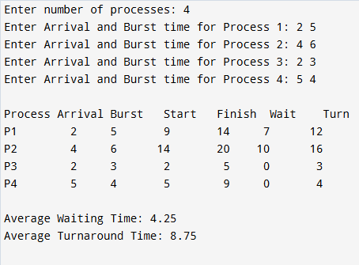

Lab 9: CPU Scheduling Simulation (Round Robin)

Objectives
Simulate basic CPU algorithm
Calculate turnaround and waiting times

Algorithm:
Programming IDE
Input dataset of processes.

Program:
#include <stdio.h>
// #include<conio.h>
void main()
{
int start[10], burst[10], need[10], execution[10], wait[10], finish[10], turn[10];
int i, ts, n, totaltime = 0, totalburst = 0;
float totalwait = 0.0, totalturn = 0.0, totalresp = 0.0;
float avgwait = 0.0, avgturn = 0.0, avgresp = 0.0;
// clrscr();
printf("Name:'Your name'\n");
printf("Enter number of processes: ");
scanf("%d", &n);
for (i = 0; i < n; i++)
{
printf("Enter process %d burst time: ", (i + 1));
scanf("%d", &burst[i]);
}
printf("Enter time slice: ");
scanf("%d", &ts);
for (i = 0; i < n; i++)
{
need[i] = burst[i];
execution[i] = 0;
wait[i] = 0;
finish[i] = 0;
turn[i] = 0;
totalburst = totalburst + burst[i];
}
while (totalburst > 0)
{
for (i = 0; i < n; i++)
{
if (execution[i] == 0)
{
start[i] = totaltime;
}
if (need[i] > ts)
{
execution[i] = execution[i] + ts;
need[i] = need[i] - ts;
totaltime = totaltime + ts;
totalburst = totalburst - ts;
}
else
{
if (need[i] > 0)
{
execution[i] = execution[i] + need[i];
totaltime = totaltime + need[i];
wait[i] = totaltime - execution[i];
finish[i] = wait[i] + burst[i];
turn[i] = wait[i] + burst[i];
totalburst = totalburst - need[i];
need[i] = 0;
}
}
}
}
printf("\n process| burst| start| wait| finish| turnaround \n");
for (i = 0; i < n; i++)
{
printf("%7d %5d %5d %5d %4d %6d \n", (i + 1), burst[i], start[i], wait[i], finish[i], turn[i]);
}
for (i = 0; i < n; i++)
{
totalwait = totalwait + wait[i];
totalturn = totalturn + turn[i];
totalresp = totalresp + start[i];
}
avgwait = totalwait / n;
avgturn = totalturn / n;
avgresp = totalresp / n;
printf("\n Average waiting time %f\n", avgwait);
printf("\n Average turnaround time %f\n", avgturn);
printf("\n Average response time %f\n", avgresp);
// getch();
}

Output
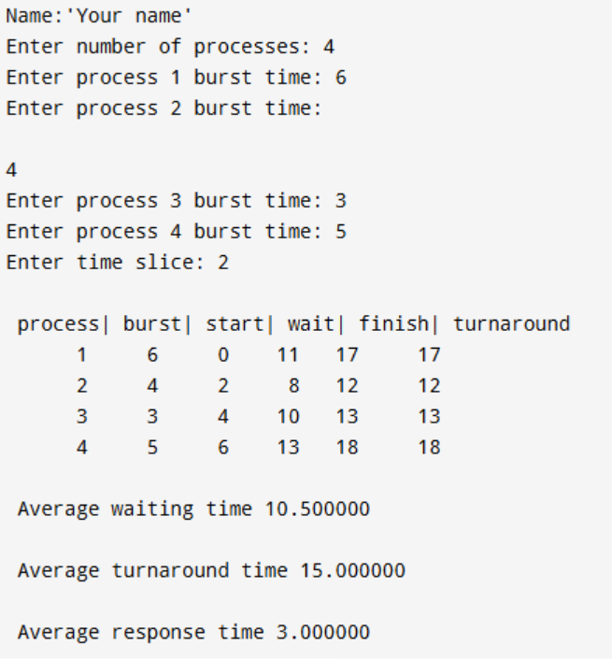

Lab 10: CPU Scheduling Simulation (Priority based)

Objectives
Simulate basic CPU algorithm.

Algorithm:
- Start
- Declare variables and arrays
Arrays for arrival time, burst time, priority, process ID
Arrays for start time, finish time, waiting time, turnaround time
Array to mark completed processes
Variables for current time, completed process count
Variables for total waiting time and total turnaround time
- Read number of processes n
- For each process i from 0 to n−1
Assign process ID pid[i] = i + 1
Set completed[i] = 0
Read arrival time, burst time, and priority
- Initialize
time = 0
completed_count = 0
- While completed_count < n do
  - Set
idx = -1 (index of selected process)
highest_priority = large value
  - For each process i from 0 to n−1
If process has arrived (arrival[i] ≤ time) and is not completed
If priority[i] < highest_priority
Update highest_priority = priority[i]
Update idx = i
  - If no process is selected (idx == -1)
Increment time by 1 (CPU remains idle)
  - Else
Set start[idx] = time
Set finish[idx] = start[idx] + burst[idx]
Calculate turnaround time: turn[idx] = finish[idx] - arrival[idx]
Calculate waiting time: wait[idx] = turn[idx] - burst[idx]
Add waiting time to total waiting time
Add turnaround time to total turnaround time
Update time = finish[idx]
Mark process as completed as completed[idx] = 1
Increment completed_count

- Display process details
Process ID, Arrival time, Burst time, Priority, Start time, Finish time, Turnaround time, Waiting time
- Calculate and display
Average Waiting Time = total waiting time ÷ n
Average Turnaround Time = total turnaround time ÷ n
- Stop

Program:
#include <stdio.h>

int main()
{
int arrival[10], burst[10], priority[10], pid[10];
int start[10], finish[10], wait[10], turn[10], completed[10];
int i, time = 0, completed_count = 0, n;
float totalwait = 0.0, totalturn = 0.0;

printf("Name: Kapil Dev Pant\n");
printf("Enter number of processes: ");
scanf("%d", &n);

// input arrival time, burst time and Priority for each process
for (i = 0; i < n; i++)
{
pid[i] = i + 1;
completed[i] = 0;
printf("Enter Arrival Time, Burst Time, Priority of Process %d: ", i + 1);
scanf("%d %d %d", &arrival[i], &burst[i], &priority[i]);
}

// Priority Scheduling' main logic
while (completed_count < n)
{
// higher number has higher priority
int idx = -1;
int highest_priority = 9999;

for (i = 0; i < n; i++)
{
if (arrival[i] <= time && completed[i] == 0)
{
if (priority[i] < highest_priority)
{
highest_priority = priority[i];
idx = i;
}
}
}

if (idx == -1)
{
time++; // CPU idle
}
else
{
start[idx] = time;
finish[idx] = start[idx] + burst[idx];
turn[idx] = finish[idx] - arrival[idx];
wait[idx] = turn[idx] - burst[idx];

totalwait += wait[idx];
totalturn += turn[idx];

time = finish[idx];
completed[idx] = 1;
completed_count++;
}
}

// Output
printf("\nProcess\tArrival\tBurst\tPriority\tStart\tFinish\tTurn\tWait\n");
for (i = 0; i < n; i++)
{
printf("P%d\t%7d\t%5d\t%8d\t%5d\t%6d\t%4d\t%4d\n",
pid[i], arrival[i], burst[i], priority[i],
start[i], finish[i], turn[i], wait[i]);
}

printf("\nAverage Waiting Time: %.2f\n", totalwait / n);
printf("Average Turnaround Time: %.2f\n", totalturn / n);

return 0;
}

Output of priority based CPU scheduling
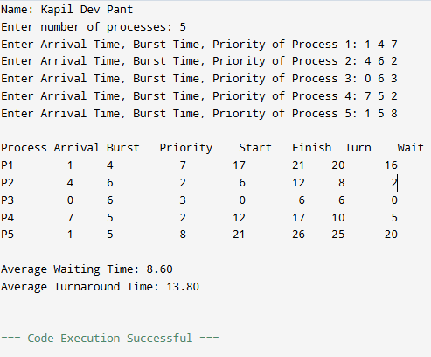

Lab 11: Page Replacement Simulation using FIFO

Objectives
Simulate basic page replacement using FIFO approach

Algorithm:
Step 1: Start the process.
Step 2: Declare the number of frames.
Step 3: Read the number of pages in the reference string.
Step 4: Read the page reference values.
Step 5: Initialize all frames as empty and set a pointer to the first frame.
Step 6: For each page in the reference string, check whether the page is already present in the frames.
- If present, it is a page hit (no replacement).
Step 7: If the page is not present (page fault):
- Replace the page that was loaded first (oldest page) in memory.
- Move the pointer to the next frame in circular order.
Step 8: Display the contents of frames after each page reference.
Step 9: Count and display the total number of page faults.
Step 10: Stop the process.

Program:
#include <stdio.h>

int main()
{
int i, j, k = 0;
int n, m;
int rs[30], p[30];
int index = 0;
int flag;

printf("Name: Kapil\n");
printf("FIFO Page Replacement Algorithm\n\n");

printf("Enter number of frames: ");
scanf("%d", &n);

printf("Enter reference string (end with -1): ");
i = 0;
while (1)
{
scanf("%d", &rs[i]);
if (rs[i] == -1)
break;
i++;
}
m = i;

/* Initialize frames */
for (i = 0; i < n; i++)
p[i] = -1;

/* FIFO logic */
for (i = 0; i < m; i++)
{
flag = 0;

/* Check page hit */
for (j = 0; j < n; j++)
{
if (p[j] == rs[i])
{
flag = 1;
break;
}
}

/* Page fault */
if (flag == 0)
{
p[index] = rs[i];
index = (index + 1) % n;
k++;

printf("\nPage fault for %d\n", rs[i]);
for (j = 0; j < n; j++)
printf("Frame %d: %d\n", j + 1, p[j]);
}
else
{
printf("\nPage hit for %d\n", rs[i]);
}
}

printf("\nTotal number of page faults = %d\n", k);

return 0;
}

Output:
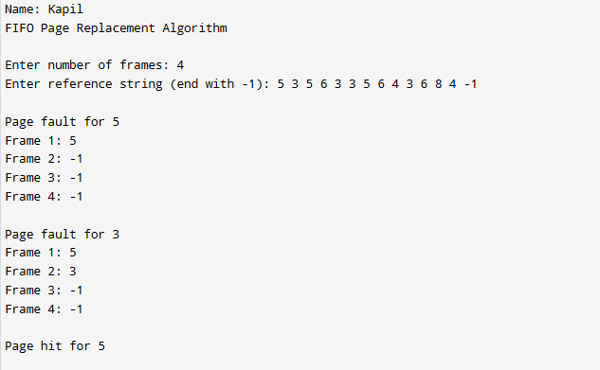

Lab 12: Page Replacement Simulation using OPT

Objectives

Program:
#include <stdio.h>

int main()
{
int i, j, k, n, m;
int rs[30], p[30];
int fault = 0, flag, index, farthest;
int pos[30];

printf("Name: Kapil Dev Pant\n");
printf("Optimal Page Replacement Algorithm\n\n");

printf("Enter number of frames: ");
scanf("%d", &n);

printf("Enter reference string (end with -1): ");
i = 0;
while (1)
{
scanf("%d", &rs[i]);
if (rs[i] == -1)
break;
i++;
}
m = i;

/* Initialize frames */
for (i = 0; i < n; i++)
p[i] = -1;

/* Optimal replacement logic */
for (i = 0; i < m; i++)
{
flag = 0;

/* Check page hit */
for (j = 0; j < n; j++)
{
if (p[j] == rs[i])
{
flag = 1;
break;
}
}

/* Page fault */
if (flag == 0)
{
fault++;

/* If empty frame exists */
for (j = 0; j < n; j++)
{
if (p[j] == -1)
{
p[j] = rs[i];
goto display;
}
}

/* Find page to replace */
for (j = 0; j < n; j++)
{
pos[j] = -1;
for (k = i + 1; k < m; k++)
{
if (p[j] == rs[k])
{
pos[j] = k;
break;
}
}
}

/* Find farthest future use */
farthest = 0;
index = 0;
for (j = 0; j < n; j++)
{
if (pos[j] == -1)
{
index = j;
break;
}
if (pos[j] > farthest)
{
farthest = pos[j];
index = j;
}
}

p[index] = rs[i];
}

display:
printf("\nAfter accessing %d:\n", rs[i]);
for (j = 0; j < n; j++)
printf("Frame %d: %d\n", j + 1, p[j]);
}

printf("\nTotal Page Faults = %d\n", fault);

return 0;
}

Output
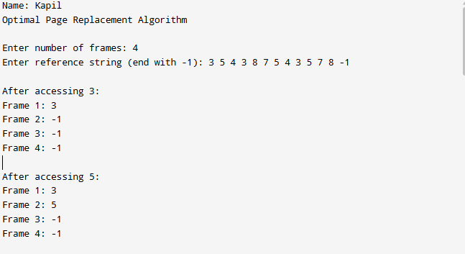

Lab 13: Page Replacement Simulation LRU

Objectives
Simulate basic CPU algorithm
Calculate turnaround and waiting times

Algorithm:
Step 1: Start the process.
Step 2: Declare the size of frames.
Step 3: Read the number of pages in the reference string.
Step 4: Read the page reference values.
Step 5: Declare frame array, counter array, and a stack (or time counter).
Step 6: For each page reference, check whether the page is already present in a frame.
- If present, update its counter (recent use).
Step 7: If the page is not present (page fault):
Select the page with the least recent counter value.
- Replace it with the new page.
Step 8: Arrange (stack) the pages according to recent usage and display frame contents after each reference.
Step 9: Display the total number of page faults.
Step 10: Stop the process.

Program:
#include <stdio.h>
int main()
{
int i, j, k, n, m;
int rs[30], p[30];
int time[30];
int fault = 0, flag, count = 0, index, least;

printf("Name: Kapil Dev Pant\n");
printf("LRU Page Replacement Algorithm\n\n");

printf("Enter number of frames: ");
scanf("%d", &n);

printf("Enter reference string (end with -1): ");
i = 0;
while (1)
{
scanf("%d", &rs[i]);
if (rs[i] == -1)
break;
i++;
}
m = i;

/* Initialize frames and time */
for (i = 0; i < n; i++)
{
p[i] = -1;
time[i] = 0;
}

/* LRU logic */
for (i = 0; i < m; i++)
{
flag = 0;
count++;

/* Page hit */
for (j = 0; j < n; j++)
{
if (p[j] == rs[i])
{
time[j] = count;
flag = 1;
break;
}
}

/* Page fault */
if (flag == 0)
{
fault++;

/* Check for empty frame */
for (j = 0; j < n; j++)
{
if (p[j] == -1)
{
p[j] = rs[i];
time[j] = count;
goto display;
}
}

/* Find least recently used page */
least = time[0];
index = 0;
for (j = 1; j < n; j++)
{
if (time[j] < least)
{
least = time[j];
index = j;
}
}

p[index] = rs[i];
time[index] = count;
}

display:
printf("\nAfter accessing %d:\n", rs[i]);
for (j = 0; j < n; j++)
printf("Frame %d: %d\n", j + 1, p[j]);
}

printf("\nTotal Page Faults = %d\n", fault);

return 0;
}

Output
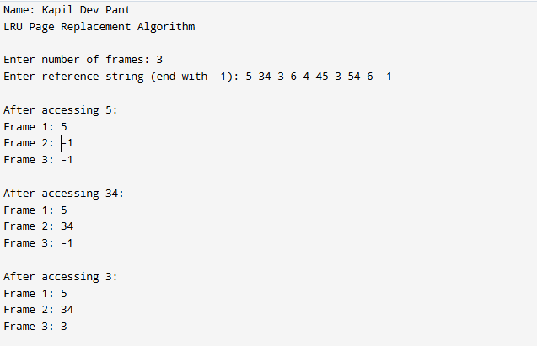

Lab 14: Page Replacement Simulation Clock

Objectives
Simulate advanced page replacement policies

Algorithm
Step 1: Start the process.
Step 2: Declare the number of frames.
Step 3: Read the number of pages in the reference string.
Step 4: Read the page reference values.
Step 5: Initialize all frames as empty and set the use (reference) bit of each frame to 0.
Step 6: Set the clock pointer to the first frame.
Step 7: For each page in the reference string, check whether the page is already present in any frame.
- If present, set its use bit to 1 (page hit).
Step 8: If the page is not present (page fault):
- Check the frame pointed by the clock pointer.
  - If the use bit is 0, replace the page with the new page.
  - If the use bit is 1, set it to 0 and move the pointer to the next frame.
- Repeat until a frame with use bit 0 is found.
Step 9: Move the clock pointer to the next frame after replacement.
Step 10: Display the frame contents after each page reference.
Step 11: Display the total number of page faults.
Step 12: Stop the process

Program
#include <stdio.h>

int main()
{
int n, m, i, j;
int frames[30], usebit[30];
int rs[30];
int pointer = 0;
int fault = 0;
int flag;

printf("Name: Kapil\n");
printf("Clock (Second-Chance) Page Replacement Algorithm\n\n");

printf("Enter number of frames: ");
scanf("%d", &n);

printf("Enter reference string (end with -1): ");
i = 0;
while (1)
{
scanf("%d", &rs[i]);
if (rs[i] == -1)
break;
i++;
}
m = i;

/* Initialize frames and use bits */
for (i = 0; i < n; i++)
{
frames[i] = -1;
usebit[i] = 0;
}

/* Clock algorithm */
for (i = 0; i < m; i++)
{
flag = 0;

/* Page hit check */
for (j = 0; j < n; j++)
{
if (frames[j] == rs[i])
{
usebit[j] = 1;
flag = 1;
break;
}
}

/* Page fault */
if (flag == 0)
{
fault++;

while (usebit[pointer] == 1)
{
usebit[pointer] = 0;
pointer = (pointer + 1) % n;
}

frames[pointer] = rs[i];
usebit[pointer] = 1;
pointer = (pointer + 1) % n;
}

/* Display frames */
printf("\nAfter accessing %d:\n", rs[i]);
for (j = 0; j < n; j++)
printf("Frame %d: %d (use=%d)\n", j + 1, frames[j], usebit[j]);
}

printf("\nTotal Page Faults = %d\n", fault);

return 0;
}

Output
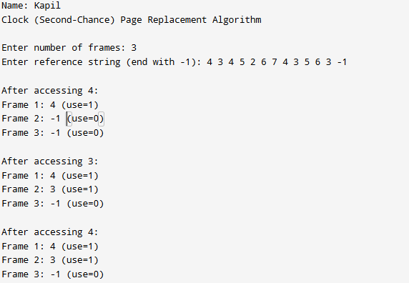

Lab 15: Page Replacement Simulation using LFU

Objectives
Simulate advanced page replacement policies

Algorithm:
Step 1: Start the process
Step 2:
the selection.
Step 8: Display the values Step 9: Stop the process

Program:
#include <stdio.h>
int main()
{
int f, p;
int pages[50], frame[10], hit = 0, count[50], time[50];
int i, j, page, flag, least, minTime, temp;
printf("Your name : 'Name'\n");
printf("Enter no of frames : ");
scanf("%d", &f);
printf("Enter no of pages : ");
scanf("%d", &p);
for (i = 0; i < f; i++)
{
frame[i] = -1;
}
for (i = 0; i < 50; i++)
{
count[i] = 0;
}
printf("Enter page no : \n");
for (i = 0; i < p; i++)
{

scanf("%d", &pages[i]);
}
printf("\n");
for (i = 0; i < p; i++)
{
count[pages[i]]++;
time[pages[i]] = i;
flag = 1;
least = frame[0];
for (j = 0; j < f; j++)
{
if (frame[j] == -1 || frame[j] == pages[i])
{
if (frame[j] != -1)
{
hit++;
}
flag = 0;
frame[j] = pages[i];
break;
}
if (count[least] > count[frame[j]])
{
least = frame[j];
}
}
if (flag)
{
minTime = 50;
for (j = 0; j < f; j++)
{
if (count[frame[j]] == count[least] && time[frame[j]] < minTime)
{
temp = j;
minTime = time[frame[j]];
}
}
count[frame[temp]] = 0;
frame[temp] = pages[i];
}
for (j = 0; j < f; j++)
{
printf("%d ", frame[j]);
}

printf("\n");
}
printf("Page hit = %d", hit);
return 0;
}

Output

Lab 16: Disk Scheduling using FCFS

Objectives
Understand disk arm scheduling

Requirements
Programming IDE.

Procedures
#include <stdio.h>
#include <stdlib.h>
int main()
{
int RQ[100], i, n, TotalHeadMoment = 0, initial;
printf("Name:'Your name'\n");
printf("Enter the number of Requests\n");
scanf("%d", &n);
printf("Enter the Requests sequence\n");
for (i = 0; i < n; i++)
scanf("%d", &RQ[i]);
printf("Enter initial head position\n");
scanf("%d", &initial);

// logic for FCFS disk scheduling

for (i = 0; i < n; i++)
{
TotalHeadMoment = TotalHeadMoment + abs(RQ[i] - initial);
initial = RQ[i];
}

printf("Total head moment is %d", TotalHeadMoment);
return 0;
}

Output

Lab 17: Disk Scheduling using SSTF
Objectives
Understand disk arm scheduling
Requirements
Programming IDE.
Procedures
Implement FCFS and SSTF scheduling.
Calculate Head movements.
Output

Lab 18: Disk Scheduling using SCAN

Objectives
Understand disk arm scheduling

Requirements
Programming IDE.

Procedures
#include <stdio.h>
#include <stdlib.h>
int main()
{
int RQ[100], i, j, n, TotalHeadMoment = 0, initial, size, move;
printf("Name:'Your name'\n");
printf("Enter the number of Requests\n");
scanf("%d", &n);
printf("Enter the Requests sequence\n");
for (i = 0; i < n; i++)
scanf("%d", &RQ[i]);
printf("Enter initial head position\n");
scanf("%d", &initial);
printf("Enter total disk size\n");
scanf("%d", &size);
printf("Enter the head movement direction for high 1 and for low 0\n");
scanf("%d", &move);

// logic for Scan disk scheduling

/*logic for sort the request array */
for (i = 0; i < n; i++)
{
for (j = 0; j < n - i - 1; j++)
{
if (RQ[j] > RQ[j + 1])
{
int temp;
temp = RQ[j];
RQ[j] = RQ[j + 1];
RQ[j + 1] = temp;
}
}
}

int index;
for (i = 0; i < n; i++)
{
if (initial < RQ[i])
{
index = i;
break;
}
}

// if movement is towards high value
if (move == 1)
{
for (i = index; i < n; i++)
{
TotalHeadMoment = TotalHeadMoment + abs(RQ[i] - initial);
initial = RQ[i];
}
// last movement for max size
TotalHeadMoment = TotalHeadMoment + abs(size - RQ[i - 1] - 1);
initial = size - 1;
for (i = index - 1; i >= 0; i--)
{
TotalHeadMoment = TotalHeadMoment + abs(RQ[i] - initial);
initial = RQ[i];
}
}
// if movement is towards low value
else
{
for (i = index - 1; i >= 0; i--)
{
TotalHeadMoment = TotalHeadMoment + abs(RQ[i] - initial);
initial = RQ[i];
}
// last movement for min size
TotalHeadMoment = TotalHeadMoment + abs(RQ[i + 1] - 0);
initial = 0;
for (i = index; i < n; i++)
{
TotalHeadMoment = TotalHeadMoment + abs(RQ[i] - initial);
initial = RQ[i];
}
}

printf("Total head movement is %d", TotalHeadMoment);
return 0;
}

Output

Lab 19: Disk Scheduling using C-SCAN

Objectives
Simulate advance disk scheduling

Requirements
Programming IDE

Procedures
#include <stdio.h>
#include <stdlib.h>
int main()
{
int RQ[100], i, j, n, TotalHeadMoment = 0, initial, size, move;
printf("Name:'Your name'\n");
printf("Enter the number of Requests\n");
scanf("%d", &n);
printf("Enter the Requests sequence\n");
for (i = 0; i < n; i++)
scanf("%d", &RQ[i]);
printf("Enter initial head position\n");
scanf("%d", &initial);
printf("Enter total disk size\n");
scanf("%d", &size);
printf("Enter the head movement direction for high 1 and for low 0\n");
scanf("%d", &move);

// logic for C-Scan disk scheduling

/*logic for sort the request array */
for (i = 0; i < n; i++)
{
for (j = 0; j < n - i - 1; j++)
{
if (RQ[j] > RQ[j + 1])
{
int temp;
temp = RQ[j];
RQ[j] = RQ[j + 1];
RQ[j + 1] = temp;
}
}
}

int index;
for (i = 0; i < n; i++)
{
if (initial < RQ[i])
{
index = i;
break;
}
}

// if movement is towards high value
if (move == 1)
{
for (i = index; i < n; i++)
{
TotalHeadMoment = TotalHeadMoment + abs(RQ[i] - initial);
initial = RQ[i];
}
// last movement for max size
TotalHeadMoment = TotalHeadMoment + abs(size - RQ[i - 1] - 1);
/*movement max to min disk */
TotalHeadMoment = TotalHeadMoment + abs(size - 1 - 0);
initial = 0;
for (i = 0; i < index; i++)
{
TotalHeadMoment = TotalHeadMoment + abs(RQ[i] - initial);
initial = RQ[i];
}
}
// if movement is towards low value
else
{
for (i = index - 1; i >= 0; i--)
{
TotalHeadMoment = TotalHeadMoment + abs(RQ[i] - initial);
initial = RQ[i];
}
// last movement for min size
TotalHeadMoment = TotalHeadMoment + abs(RQ[i + 1] - 0);
/*movement min to max disk */
TotalHeadMoment = TotalHeadMoment + abs(size - 1 - 0);
initial = size - 1;
for (i = n - 1; i >= index; i--)
{
TotalHeadMoment = TotalHeadMoment + abs(RQ[i] - initial);
initial = RQ[i];
}
}

printf("Total head movement is %d", TotalHeadMoment);
return 0;
}

Output

Lab 20: Disk Scheduling using LOOK
Objectives
Understand disk arm scheduling
Requirements
Programming IDE.
Procedures
Implement FCFS and SSTF scheduling.
Calculate Head movements.
Output

Lab 21: Disk Scheduling using C-LOOK
Objectives
Simulate advance disk scheduling
Requirements
Programming IDE
Procedures
Implement SCAN, C-SCAN, LOOK, C-LOOK.
Run with sample disk requests
Output

Lab 22:
Objectives
Simulate advance disk scheduling
Requirements
Programming IDE
Procedures
Implement SCAN, C-SCAN, LOOK, C-LOOK.
Run with sample disk requests
Output

Lab 20: Simulate Banker’s Algorithm for Deadlock Avoidance

Objectives
Simulate advance disk scheduling

Requirements
Programming IDE

Program:
#include <stdio.h>

int main()
{
int n, m; // n = processes, m = resources
int i, j;

printf("Enter number of processes: ");
scanf("%d", &n);

printf("Enter number of resource types: ");
scanf("%d", &m);

int total[m], available[m], work[m];
int max[n][m], allocation[n][m], need[n][m];
int finish[n], safe[n];

/* Total instances of each resource */
printf("\nEnter total instances of each resource:\n");
for (j = 0; j < m; j++)
scanf("%d", &total[j]);

/* Maximum resources needed to complete each process */
printf("\nEnter MAX resources needed for each process:\n");
for (i = 0; i < n; i++)
{
printf("Process P%d:\n", i);
for (j = 0; j < m; j++)
scanf("%d", &max[i][j]);
}

/* Currently allocated resources */
printf("\nEnter ALLOCATION for each process:\n");
for (i = 0; i < n; i++)
{
printf("Process P%d:\n", i);
for (j = 0; j < m; j++)
scanf("%d", &allocation[i][j]);
}

/* Calculate NEED matrix */
for (i = 0; i < n; i++)
for (j = 0; j < m; j++)
need[i][j] = max[i][j] - allocation[i][j];

/* Calculate AVAILABLE resources */
for (j = 0; j < m; j++)
{
available[j] = total[j];
for (i = 0; i < n; i++)
available[j] -= allocation[i][j];

work[j] = available[j];
}

/* Initialize finish array */
for (i = 0; i < n; i++)
finish[i] = 0;

/* Safety Algorithm */
int count = 0;
while (count < n)
{
int found = 0;

for (i = 0; i < n; i++)
{
if (!finish[i])
{
int canExecute = 1;

for (j = 0; j < m; j++)
{
if (need[i][j] > work[j])
{
canExecute = 0;
break;
}
}

if (canExecute)
{
for (j = 0; j < m; j++)
work[j] += allocation[i][j];

safe[count++] = i;
finish[i] = 1;
found = 1;
}
}
}

if (!found)
{
printf("\nSystem is in UNSAFE state\n");
return 0;
}
}

/* Print Safe Sequence */
printf("\nSystem is in SAFE state\n");
printf("Safe Sequence: ");
for (i = 0; i < n; i++)
printf("P%d ", safe[i]);

return 0;
}

Output:
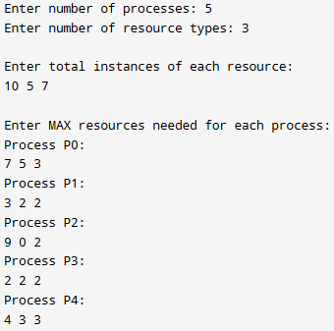
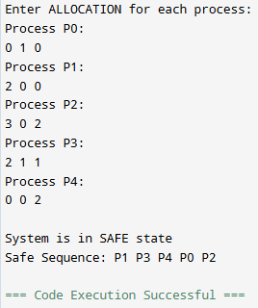

Lab 21: Simulate Banker’s Algorithm for Deadlock Prevention

Objectives:
Deadlock prevention avoids deadlock by structurally ensuring that at least one of the necessary conditions for deadlock never holds, such as disallowing partial resource allocation.

Requirements:
Programming IDE

Program:
#include <stdio.h>

int main()
{
int n, m; // n = number of processes, m = number of resources
int i, j;

printf("Name: Kapil Dev Pant\n");
printf("Enter number of processes: ");
scanf("%d", &n);

printf("Enter number of resource types: ");
scanf("%d", &m);

int available[m];
int request[n][m];

/* Input available resources */
printf("\nEnter available instances of each resource:\n");
for (j = 0; j < m; j++)
scanf("%d", &available[j]);

/* Input maximum request of each process */
printf("\nEnter resource requests of each process:\n");
for (i = 0; i < n; i++)
{
printf("Process P%d:\n", i);
for (j = 0; j < m; j++)
scanf("%d", &request[i][j]);
}

printf("\n--- Resource Allocation ---\n");

/* Deadlock Prevention Logic */
for (i = 0; i < n; i++)
{
int canAllocate = 1;

for (j = 0; j < m; j++)
{
if (request[i][j] > available[j])
{
canAllocate = 0;
break;
}
}

if (canAllocate)
{
printf("Resources allocated to Process P%d:\n", i);
for (j = 0; j < m; j++)
{
available[j] -= request[i][j];
printf(" R%d = %d\n", j, request[i][j]);
}
}
else
{
printf("Request of Process P%d DENIED (to prevent deadlock)\n", i);
}
}

/* Remaining resources */
printf("\nRemaining Available Resources:\n");
for (j = 0; j < m; j++)
printf("R%d = %d\n", j, available[j]);

return 0;
}

Output:

Lab 22: Mini OS Model (User Space)

Objectives:
- Design a model OS using open-source guidelines.
- Simulate scheduling, paging and toy filesystem.

Requirements:
- Programming IDE
- Linux/windows environment.

Procedure:
- Develop simple shell for commands.
- Implement scheduler module.
- Implement paging and VFS modules.
- Document code using open-source practices.

Output:

Lab 23: Simple Shell programming
- Check if number is odd or even
- Check if given is leap year or not
- Find factorial of a number
- Swap two integers

Objectives:
To familiarize students with shell and write shell programs by using conditional, branching and looping statement

Requirements:
Programming IDE

Program:
Implement SCAN, C-SCAN, LOOK, C-LOOK.
Run with sample disk requests
Output

Lab 24:

Objectives:
Simulate advance disk scheduling

Requirements:
Programming IDE

Program:
Implement SCAN, C-SCAN, LOOK, C-LOOK.
Run with sample disk requests

Output:

